ALU flag block design
By Pongsapat Boonpong
Date | Change
29 June 2026 | Created the document
30 June 2026 | Add the basic description for flag blocks

Purpose
The purpose of the document is to explain the function of each sub-block inside the ALU (called “L3”) to understand how it’ll work.
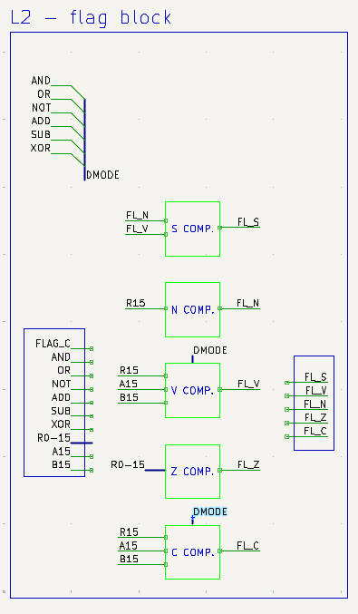
Figure 1 : the diagram of the ALU's flag block

From figure 1, one will see that the flag block will have a following L3 blocks:
-Signed computation block (S. COMP)
-Negative computation block (N. COMP)
-Overflow computation block (V. COMP)
-Zero computation block (Z. COMP)
-Carry computation block (C. COMP)
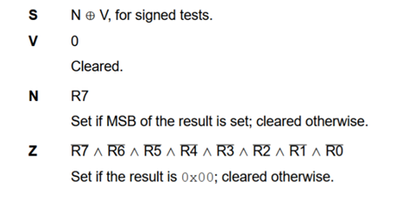
Figure 2 : flags for Ra, Rb
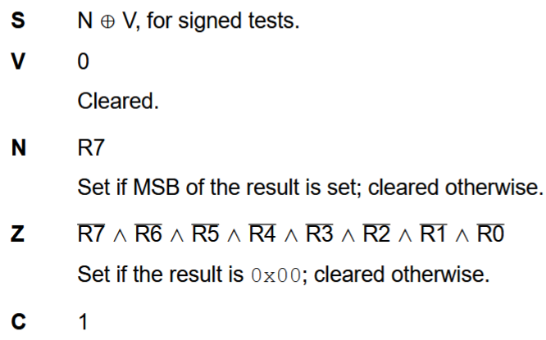
Figure 3 : Flags for NOT Ra
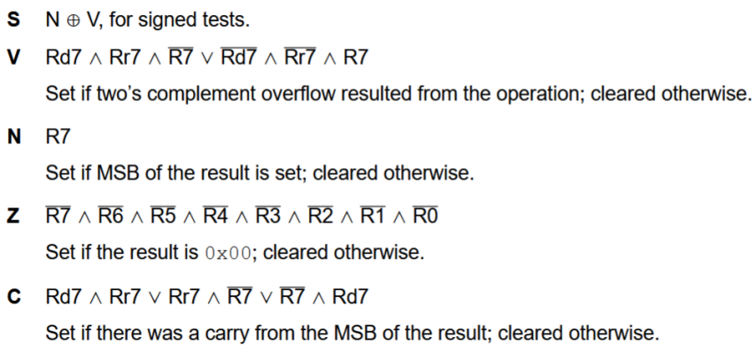
Figure 4 : Flags for ADD Ra, Rb

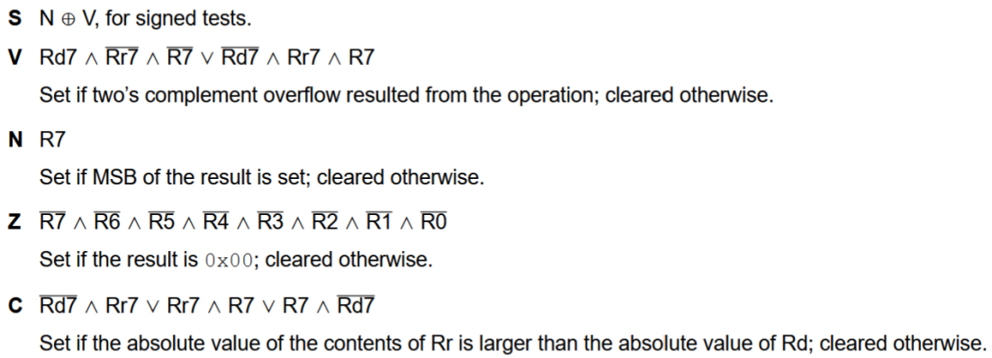
Figure 5 : the flag for SUB Ra, Rb
Signed computation block
Signed computation block is the block that compiles the sign flag, with computing conditions not changed from the ALU mode.

Negative computation block
Negative computation block is the block that compiles the negative flag, with computing conditions not changed from the ALU mode.

Overflow computation block
Overflow computation block is the block that compiles the overflow flag, with computing conditions not changed from the ALU mode.

Zero computation block
Zero computation block is the block that compiles the zero flag, with computing conditions not changed from the ALU mode.

Carry computation block
Carry computation block is the block that compiles the carry flag, with computing conditions changed from the ALU mode.

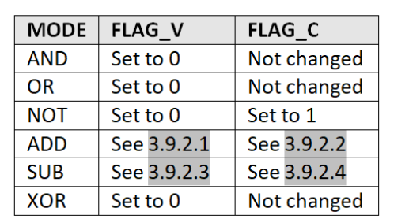
Figure 6 : the table for logic for the flag from CpuDesign.docx

